**PREGNANCY TEST- TYPES AND RESULT**

Pregnancy is not a hard to verify thing. Medical technologies have made it possible to check pregnancy at home via home pregnancy test or pregnancy test kit. The procedure is clearly mentioned on the packets and tests are confirmed in minutes. Now, how soon can I do pregnancy test to check whether I am pregnant or not? At what time periods will results be accurate? Let’s find out together.

**How soon can I do pregnancy test?**

* A missed period can be a sign!

If it is normal, consult your doctor. If it’s not, take the test and make sure what’s going on.

* Sudden vomiting and feeling of exhaustion or nausea.

If your health unexpectedly gets down, it might be a possibility that you are pregnant.

* Swollen breasts and urinating more than usual?

Check if you feel visual changes in your body after having an unprotected sex.

Above symptoms shows when to take pregnancy tests.

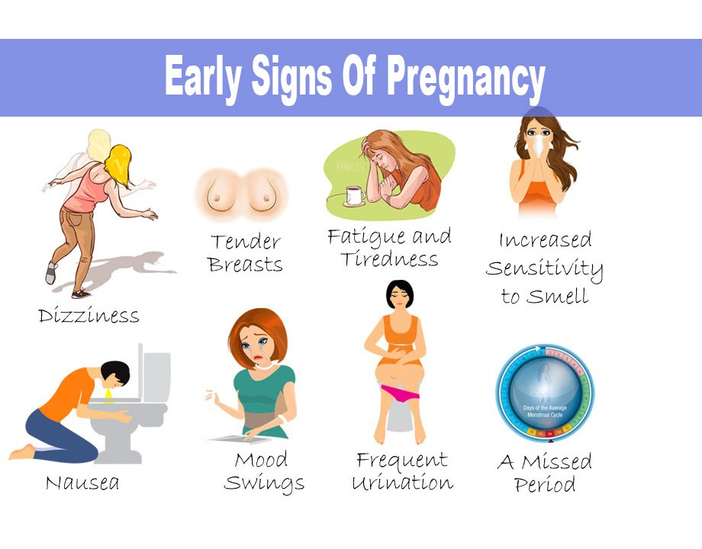

**How pregnancy is tested?**

Female bodies become sensitive and soft during early pregnancy. After implantation (when the fertilized egg sticks to walls of uterus), Human Chorionic Gonadotropin (hCG) hormone is produced by placenta in the body. Excess of this hormone can easily be detected through various tests by testing urine or blood and hence, pregnancy can be detected.

The sooner you test your pregnancy, the better you can keep control of various aspects related to pregnancy and pregnancy tests.

**When to take pregnancy test?**

These days it is easier to test pregnancy even at home by yourself! So don’t delay and reach out to nearby medical stores and make sure you know best of your body behaviour. Take appropriate measures if your pregnancy test is positive.

**Types of Pregnancy tests**

There are major two types of pregnancy tests. Pregnancy can be tested via testing sample of blood or urine. A hormone produced by body when on pregnancy, Human Chorionic Gonadotropin reacts with a chemical present on the pregnancy kit and a change in colour confirms pregnancy. Following types of pregnancy tests can be done at home or doctor’s lab as requirements demand:

1. Home pregnancy test kits

* It is an easily available and inexpensive test.
* Results may take a few minutes as the reaction may take some time.
* When to check? You can check on day 1 after first missed periods if you have doubts. It might not show positive pregnancy test results sometimes, check again after 3-4 days and verify your status. It’s better to know rather than remain in doubt!
* If not satisfied, consult your doctor and take her advice.

1. Clinical urine test

* Easily available and a bit costly than home pregnancy test kits.
* Results are expected to come in a week to be 100% clear.

1. Blood test

* It detects the hCG hormone by two different methods: Qualitative method and Quantitative method.

In qualitative method, hCG is reacted with a chemical and colour change is observes. It doesn’t always give an accurate and stable results.

In quantitative method, amount of hCG is determined and tested. It is far more accurate and shows the pregnancy time too, if positive.

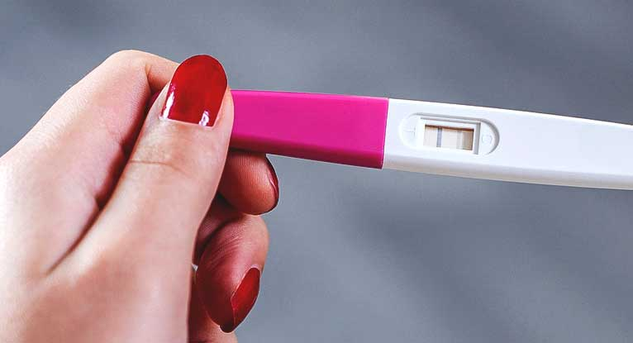

**How to use home pregnancy test kits at home?**

* Some devices require urine stream to be flowed upon it.
* Some devices instruct to use a cup to store urine and using a dropper let go a few drops on the tester.
* Other devices need to dipped into the urine cup to test.

After a few minutes, the device shows red lines as a symbol of positive test. Or, nowadays digital devices blink a ‘pregnant’ or ‘not pregnant’ words directly for better understanding. Not every time you try and check on the device after a missed period means that you are pregnant. It might not be a correct time to check upon whether pregnancy test is positive or not. For self-assurance, at least check 2 times and if you are still getting positives, run to your doctor to confirm!

**Can the home pregnancy tests be relied upon? How soon can I do pregnancy test through this?**

With the comfort comes credibility. Fake products are out there in the market! Check on the labels and surf internet, this might help.

**Checked on right time?**

It also depends on what time of your menstrual cycle you take the test! When to take pregnancy test then? Before a missed period, it is difficult to make sure that you are pregnant or not! hCG hormone isn’t generated instantly in the body. It might give you a false negative.

**Tested correctly or impatience took over?**

Don’t make a hustle when taking the test. Choose when to take pregnancy test and between various available types of pregnancy tests and give the device ample time to work and get back with precise pregnancy test results.

**NOW! What if pregnancy test is positive?**

How soon I do pregnancy test to make sure I’m walking straight? Some life decisions are totally dependent on us. While others can’t be controlled. Pregnancy depends on various other factors too that stands important beyond our consent.

**What to do if pregnancy test is positive?**

It depends on you whether to continue the pregnancy or not. If you chose to continue, consult your doctor and take proper medication and follow the diets beneficial for the moment. If you opt to abort, there are some complications you might need to go through.

There are two ways of adoption: either by medical abortion (taking abortion pills) or by surgical abortion.

* Women with pre-existing medical conditions who are not able to bear extreme conditions can’t go for abortions.
* Medical abortion method works under maximum 10 weeks of pregnancy i.e. 2.5 months. Beyond that, surgical abortion method is applicable.
* Women with heart, kidney or liver problems aren’t allowed on taking abortions.
* Other factors like bleeding disorders, adrenal gland problems risk the person’s life going for abortion.
* Women taking anti-clotting medication too needs to be careful about the step taken.

Above mentioned factors can risk your life. Make sure you check every aspect to steer clear.

**Two terms that might confuse you but exists**

1. False positive
2. False negative

**False positive**

A type of pregnancy where pregnancy test results are positive but is not an actual pregnancy. How? Go ahead! In medical terms, after intercourse the fertilized egg must reach uterus to grow. If it doesn’t do so, it can’t further be nourished and eventually the egg dies leading to ‘No Positive Pregnancy Test Results. This condition is known to us as False positive. It might occur due to menopause, ectopic pregnancy (the fertilized egg ending up in fallopian tubes or abdominal cavity) or might be some unsuitable ovarian conditions.

**False negative**

You might face a situation where you are actually pregnant but your pregnancy test results deny it. Not to worry. Take the pregnancy tests again within a gap of 3-4 days interval. It might occur due to excess dilution of urine after intake of specific food items. Take the test early morning before eating when the urine is less diluted. Also, wait for the pregnancy test results to show up. It might happen that the expected reaction takes time to signify the green flag!

If you are so sure to get positive pregnancy test results, then you may consult your doctor, discuss the factors and know the possibilities.

**Conclusion**

Don’t get hyper under unexpected situations. Every thing happens for a reason. Keep calm and look for it!